2015
PERMACULTURE
Design Certification Course
Through The Seasons Permaculture Design Course!
The third weekend of each month, April through November, 2015

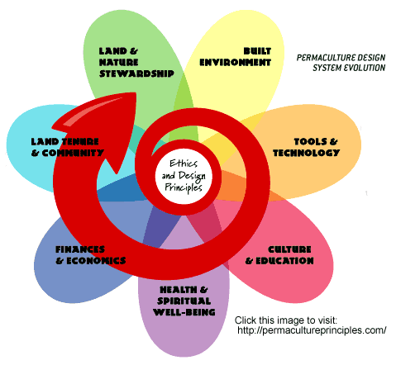

Join us in the Pikes Peak Region for a Through-the-Seasons Permaculture Design Certification Course… Learn the principles and ethics of Permaculture Design, earth centered education, natural building, building food systems, relocalize your life and power down your energy needs. Much, much more! This beautiful course offers real solution for ourselves and the future as we seek to heal ourselves and heal the land. Students will actively participate in planning and designing a project site. Come learn with us!

INSTRUCTORS: Becky Elder, Marco Lam, Sandy Cruz & other guests

COST: $1050 by December 31st, $1150 by February 15th, $1250 after... Couples receive a $100 discount for the 2nd tuition.
There are a limited number of work study positions available!

CONTACT: Becky Elder (719) 685-0290 becky@blueplanetearthscapes.com

Sponsored by: Pikes Peak Permaculture, Transition Manitou &
Blue Planet Earthscapes

